**PA Pool Project – Requirements Document**

**EQUIPHILLO**

**System Requirements**

**[SR_0010]**

* The BLE Keyboard project shall use the STM32F446RE development board for its implementation.

**[SR_0020]**

* The BLE Keyboard project shall use the X-NUCLEO-BNRG2A1 expansion board.

**[SR_0025]**

* The X-NUCLEO-BNRG2A1 expansion board shall have the BLUENRG-M2SP Bluetooth processor.

**[SR_0030]**

* The BLE Keyboard project shall integrate a Bluetooth stack that complies with the Bluetooth stack protocol for the chosen Bluetooth application processor that manages the BLE communication.

**[SR_0040]**

* The BLE Keyboard project shall Implement FreeRTOS as the Real-Time Operating System to manage multitasking, task scheduling, and efficient resource utilization.

**[SR_0050]**

* The BLE Keyboard project shall Implement peripheral libraries compatible with STM32 microcontrollers for simplified interaction with peripherals like GPIO, UART, and Bluetooth modules.

**[SR_0060]**

* The BLE Keyboard project shall handle all the necessary logic for the keypress and debouncing of the matrix keyboard keys.

**[SR_0070]**

* The BLE Keyboard project shall implement secure Bluetooth pairing mechanisms to establish and maintain secure connections between devices.

**[SR_0080]**

* The BLE Keyboard project shall implement data streaming capabilities for transmitting keyboard inputs wirelessly.

**[SR_0090]**

* The BLE Keyboard project shall integrate security features to ensure the confidentiality and integrity of Bluetooth communication.

**[SR_0130]**

* The BLE Keyboard project shall be constantly energized via the board mini B connector (CN1 ST-LINK USB).

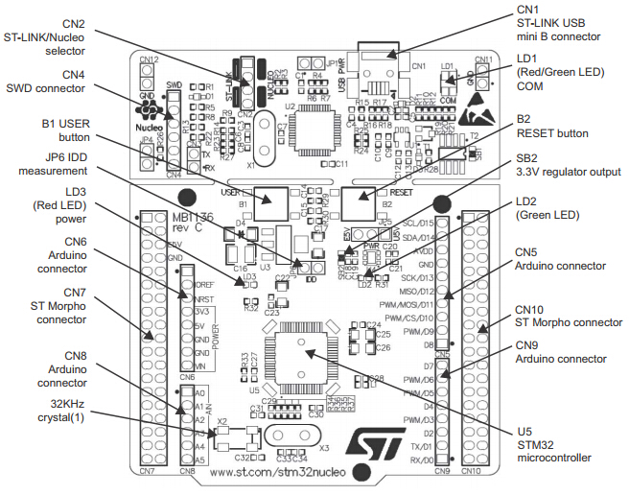

*Image 1. STM32F446RE schematic.*